Lab of Biomechanics and Ergonomics

Available instruments and analysis systems:
- Optoelectronic system for motion analysis VICON T-series with 10 cameras
- Two force- plates Bertec 4060-05
- Wireless Electromyographic System Myon MA‐320 EMG system (Myon AG, Schwarzenberg, Switzerland) with 8 canals.
- Isokinetic Dynamometer CYBEX NORM (common use for all labs)
- Treadmill Technogym

Lab personnel:
Permanent research staff:
Giannis Giakas, Professor in Biomechnics (Head of the Lab)
Thanasis Tsiokanos, Assoc. Professor in Biomechanics
Panagiotis Tsaklis, Professor in Biomechnics & Ergonomics
Themis Tsatalas, Permanent Teaching Staff

Interim staff members:
Christos Kokotis, PhD Canditate
Stelios Zakynthinakis, PhD Canditate
Stefanos Kalotychos, Msc Canditate
Panagiotis Papatheodorou, Msc Canditate
Dimitris Despotoulis, Msc Canditate
Christos Papadopoulos, Msc Canditate
Giorgos Antonopoulos, Msc Canditate
Evagelia Karabina, Undergraduate Student
Erini Dolapsaki, Undergraduate Student
Artemis Zarkadoula, Undergraduate Student

Contact: Themis Tsatalas, email: ttsatalas@pe.uth.gr, tel.: +30 24310 47065

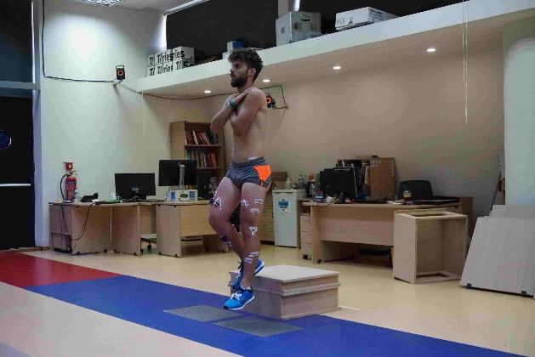 | 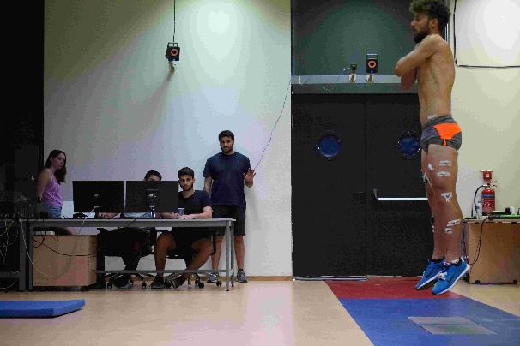
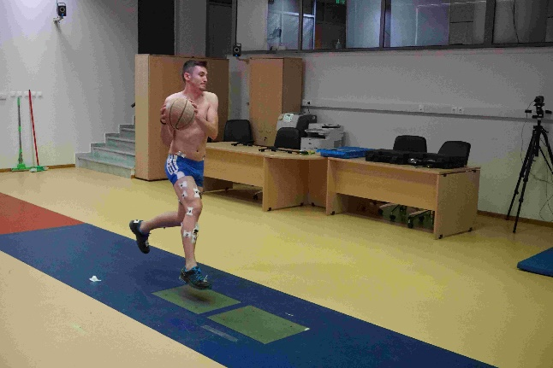 | 